
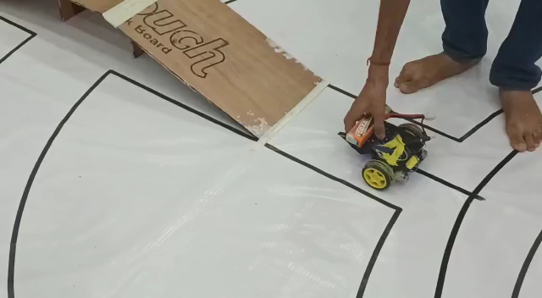

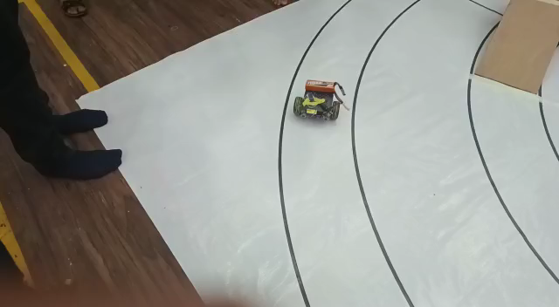

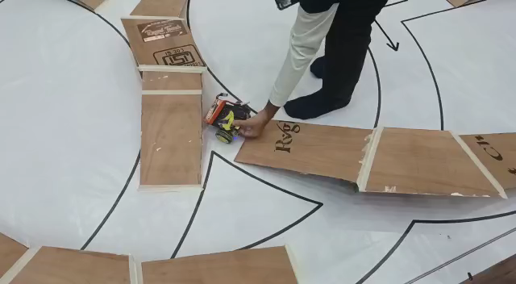

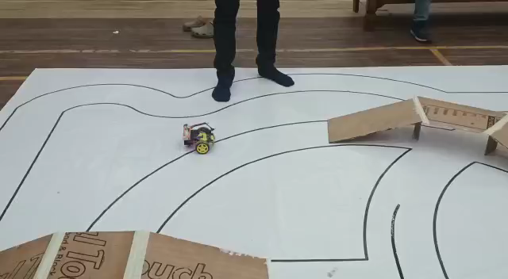
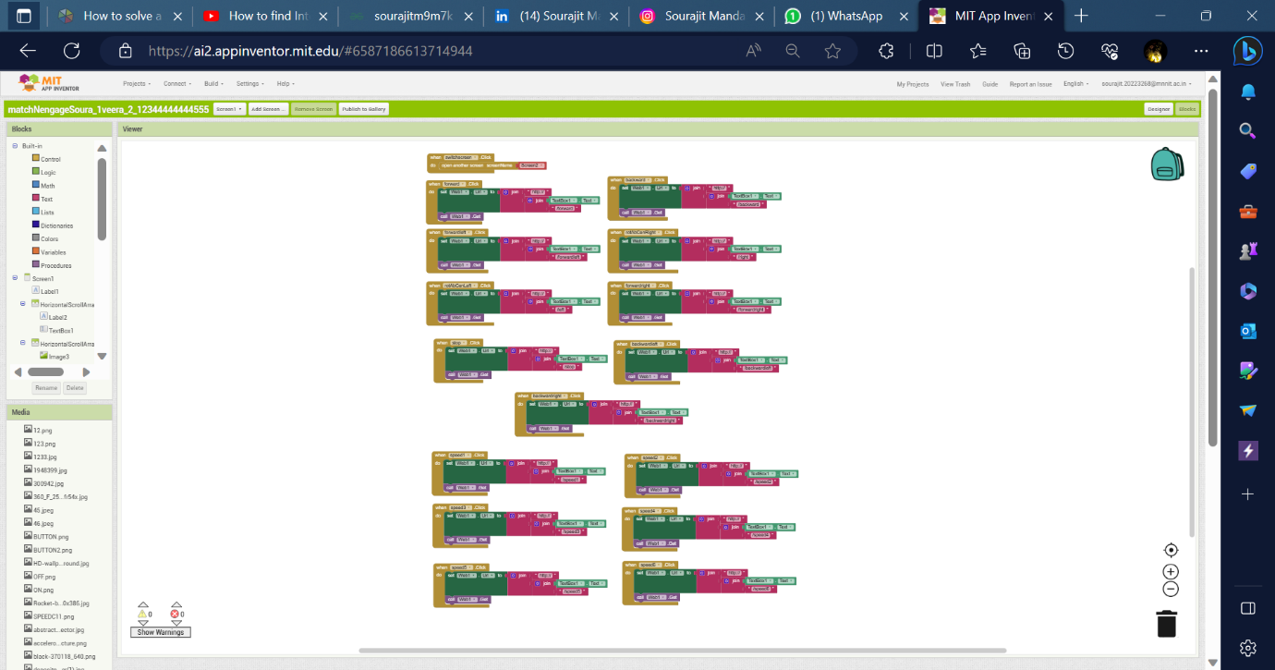

#include <ESP8266WiFi.h>

#define m1 D8
#define m2 D7
#define m3 D4
#define m4 D3
#define s1 D5
#define s2 D6

int speed = 0;

WiFiClient client;

WiFiServer server(80);
const char* ssid = "Sourajit";

const char* password = "sourajitmandal";

String data ="";

void setup(){
Serial.begin(115200);

connectWiFi();

server.begin();
pinMode(m1,OUTPUT);
pinMode(m2,OUTPUT);
pinMode(m3,OUTPUT);
pinMode(m4,OUTPUT);
pinMode(s1,OUTPUT);
pinMode(s2,OUTPUT);
Serial.begin(115200);

}
void loop()

{

client = server.available();

if (!client) return;

data = checkClient ();

if(data == "speed1" ) speed = 40;

else if(data == "speed2") speed = 60;

else if(data == "speed3") speed = 110;

else if(data == "speed4") speed = 150;

else if(data == "speed5") speed = 200;

else if(data == "speed6") speed = 254;

if (data == "forward" ) forward(speed);

else if (data == "backward" ) backward(speed);

else if (data == "left" ) rotAbCendirL(speed);

else if (data == "right") rotAbCendirR(speed);

else if (data == "stop") stop();

else if (data == "backwardleft") backwardLeft(speed);

else if (data == "backwardright") backwardRight(speed);

else if (data == "forwardleft") forwardLeft(speed);

else if (data == "forwardright") forwardRight(speed);

}

void connectWiFi()

{

Serial.println("Connecting to WIFI");

WiFi.begin(ssid, password);

while ((!(WiFi.status() == WL_CONNECTED)))

{

delay(300);

Serial.print("..");

}

Serial.println("");

Serial.println("WiFi connected");

Serial.println("NodeMCU Local IP is : ");

Serial.print((WiFi.localIP()));

}

void forward(int speed){
digitalWrite(m1,LOW);
digitalWrite(m2,HIGH);
digitalWrite(m3,HIGH);
digitalWrite(m4,LOW);
if (speed < 130){
analogWrite(s1,200);
analogWrite(s2,200);
delay(25);
analogWrite(s1,speed);
analogWrite(s2,speed);
} else {
analogWrite(s1,speed);
analogWrite(s2,speed);
}

}

void forwardLeft(int speed){
digitalWrite(m1,LOW);
digitalWrite(m2,HIGH);
digitalWrite(m3,HIGH);
digitalWrite(m4,LOW);
analogWrite(s1,110);
delay(25);
analogWrite(s1,50);
analogWrite(s2,110);
}

void forwardRight(int speed){
digitalWrite(m1,LOW);
digitalWrite(m2,HIGH);
digitalWrite(m3,HIGH);
digitalWrite(m4,LOW);
analogWrite(s2,110);
delay(50);
analogWrite(s2,50);
analogWrite(s1,110);
}

void backwardLeft(int speed){
digitalWrite(m1,HIGH);
digitalWrite(m2,LOW);
digitalWrite(m3,LOW);
digitalWrite(m4,HIGH);
analogWrite(s1,110);
delay(50);
analogWrite(s1,50);
analogWrite(s2,110);
}

void backwardRight(int speed){
digitalWrite(m1,HIGH);
digitalWrite(m2,LOW);
digitalWrite(m3,LOW);
digitalWrite(m4,HIGH);
analogWrite(s2,110);
delay(50);
analogWrite(s2,50);
analogWrite(s1,110);
}

void backward(int speed){
digitalWrite(m1,HIGH);
digitalWrite(m2,LOW);
digitalWrite(m3,LOW);
digitalWrite(m4,HIGH);
if (speed < 130){
analogWrite(s1,200);
analogWrite(s2,200);
delay(25);
analogWrite(s1,speed);
analogWrite(s2,speed);
} else {
analogWrite(s1,speed);
analogWrite(s2,speed);
}
}

void rotAbCendirL(int speed){
digitalWrite(m1,HIGH);
digitalWrite(m2,LOW);
digitalWrite(m3,HIGH);
digitalWrite(m4,LOW);
if (speed < 130){
analogWrite(s1,200);
analogWrite(s2,200);
delay(25);
analogWrite(s1,speed);
analogWrite(s2,speed);
} else {
analogWrite(s1,speed);
analogWrite(s2,speed);
}
}

void rotAbCendirR(int speed){
digitalWrite(m1,LOW);
digitalWrite(m2,HIGH);
digitalWrite(m3,LOW);
digitalWrite(m4,HIGH);
if (speed < 130){
analogWrite(s1,200);
analogWrite(s2,200);
delay(25);
analogWrite(s1,speed);
analogWrite(s2,speed);
} else {
analogWrite(s1,speed);
analogWrite(s2,speed);
}
}

void stop(){
digitalWrite(m1,LOW);
digitalWrite(m2,LOW);
digitalWrite(m3,LOW);
digitalWrite(m4,LOW);
}

// void square(){
// digitalWrite(m1,LOW);
// digitalWrite(m2,HIGH);
// digitalWrite(m3,HIGH);
// digitalWrite(m4,LOW);
// analogWrite(s1,200);
// analogWrite(s2,200);
// delay(25);
// analogWrite(s1,40);
// analogWrite(s2,40);
// delay(4500);

// digitalWrite(m1,HIGH);
// digitalWrite(m2,LOW);
// digitalWrite(m3,HIGH);
// digitalWrite(m4,LOW);
// analogWrite(s1,110);
// delay(25);
// analogWrite(s1,50);
// analogWrite(s2,110);
// delay(900);

// square();

// }

// void increasingForward(){
// digitalWrite(m1,LOW);
// digitalWrite(m2,HIGH);
// digitalWrite(m3,HIGH);
// digitalWrite(m4,LOW);
// analogWrite(s1,200);
// analogWrite(s2,200);
// delay(25);
// int speedf = 40;
// for(int i = 1; i <= 200 ; i++){
// analogWrite(s1,speedf);
// analogWrite(s2,speedf);
// delay(50);
// speedf++;
// if (data == "forward") forward(speed);

// else if (data == "backward") backward(speed);

// else if (data == "left") rotAbCendirL(speed);

// else if (data == "right") rotAbCendirR(speed);

// else if (data == "stop") stop();

// //else if (data == "forwardleft") /*forwardLeft(speed)*/ increasingForward();

// else if (data == "forwardright") /*forwardRight(speed)*/ increasingBackward();

// else if (data == "backwardleft") backwardLeft(speed);

// else if (data == "backwardright") backwardRight(speed);
// }

// }

// void increasingBackward(){
// digitalWrite(m1,HIGH);
// digitalWrite(m2,LOW);
// digitalWrite(m3,LOW);
// digitalWrite(m4,HIGH);
// analogWrite(s1,200);
// analogWrite(s2,200);
// delay(25);
// int speedf = 40;
// for(int i = 1; i <= 200 ; i++){
// analogWrite(s1,speedf);
// analogWrite(s2,speedf);
// delay(50);
// speedf++;

// if (data == "forward") forward(speed);

// else if (data == "backward") backward(speed);

// else if (data == "left") rotAbCendirL(speed);

// else if (data == "right") rotAbCendirR(speed);

// else if (data == "stop") stop();

// else if (data == "forwardleft") /*forwardLeft(speed)*/ increasingForward();

// //else if (data == "forwardright") /*forwardRight(speed)*/ increasingBackward();

// else if (data == "backwardleft") backwardLeft(speed);

// else if (data == "backwardright") backwardRight(speed);
// }

// }

/**RECEIVE DATA FROM the APP **/

String checkClient (void)

{

while(!client.available()) delay(1);

String request = client.readStringUntil('\r');

request.remove(0, 5);

request.remove(request.length()-9,9);

return request;

}

